

United Curriculum
Science – Physics
Year 7
Practice Paper
Time: 30 minutes
Surname:
First name(s):
Class name / number:
You must have: A pencil, ruler, and a calculator. Instructions
- Fill in the boxes on the front page.
- Use a black ink pen.
- The marks for each question are shown.
- Answer the questions in the space provided.
- Cross through any work you do not want to be marked.

Advice
- Read each question carefully before you begin.
- Try your best to answer every question. If you have time, go back and review your answers.
For Teacher use only:

TOTAL MARKS
30

Question 1 (6 marks)

1a. What is the name of the energy store that all moving objects have?

Tick the correct answer.

Tick (✓)
Elastic
Gravitational
Kinetic
Velocity

1

1b. What is the name of the energy store that is increasing when an object is lifted into the air?
Tick the correct answer.

Tick (✓)
Elastic
Gravitational
Magnetic
Thermal

1

1c. What is the name of the energy store that is always decreasing when a battery is being used?
Tick the correct answer.

Tick (✓)
Electric
Chemical
Magnetic
Thermal

1

1d. Energy is always conserved during all energy transfers.

What does ‘energy is conserved’ mean?
1

The image below shows a hot water bottle.
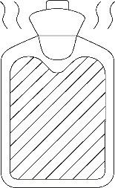

The hot water bottle is filled with hot water. The hot water bottle cools down.
1e. What is the name of the energy store that is decreasing as the bottle cools down?

1f. What happens to the energy that decreases in the hot water as it cools down?
1

Turn over for the next question
1

Question 2 (9 marks)
1

The diagram below shows the forces on a car moving forwards.

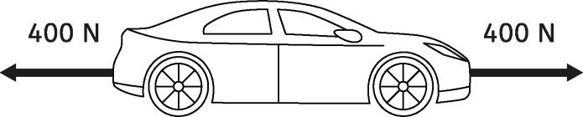

2a. Which phrase below is a description of the car's movement?

Tick the correct answer.

Tick (✓)
Constant speed
Slowing down
Speeding up
Stationary

The forces on the car change.

Below shows the new forces on the car.
1

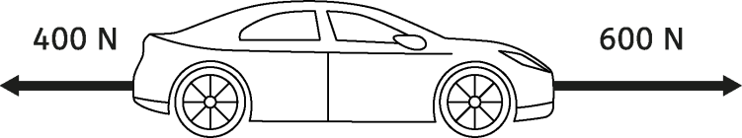

2b. Which phrase below is a description of the car's movement?

Tick the correct answer.

Tick (✓)
Constant speed
Slowing down
Speeding up
Stationary

The forces on the car change again. Below shows the new forces on the car.
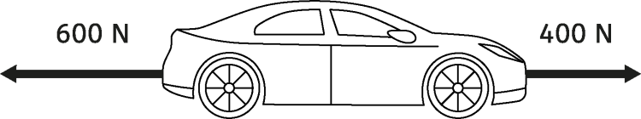

2c. Which phrase below is a description of the car's movement?

Tick the correct answer.

Tick (✓)
Constant speed
Slowing down
Speeding up
Stationary

2d. Calculate the size of the overall force on the car in the diagram above.
1

Give the direction of the overall force.

Size: N

Direction:
2

The car is parked on the road. It is not moving.
4
The car has a weight of 2000 N.

2e. Draw a free-body force diagram of the car at rest on the road.

Use a dot () to represent the car.

Draw arrows to represent each of the forces.

Label each force with its name and its size in Newtons. Use a pencil and ruler.



Question 3 (8 marks)

A teacher wanted to investigate friction.
They used a force meter to pull an object across different surfaces. The diagram shows the apparatus they used.
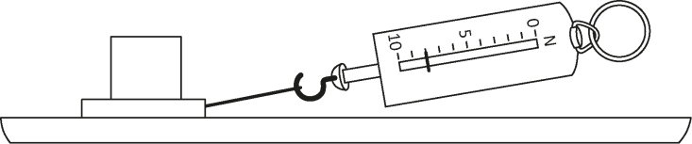

This is the method they used:

- Place the object on the surface and attach a force meter.
- Gently pull on the force meter until the object starts to slide.
- Measure the force as it just starts to slide.
- Record the force in the table.
- Repeat the measurement three times.
- Change the surface and repeat.

3a. What is the dependent variable in this investigation?

3b. Suggest two control variables for this investigation.
2
1

The table below shows the results from the investigation:

 | Force to start sliding (N)
Surface | 1st repeat | 2nd repeat | 3rd repeat
A | 5 | 6 | 5
B | 7 | 7 | 8
C | 9 | 9 | 9
D | 13 | 12 | 13

3c. Which surface has the most friction?

Tick the correct answer.

Tick (✓)
A
B
C
D

3d. Which of the following words best describes the results in the table?
1

Tick the correct answer.

Tick (✓)
Anomalous
Predictable
Repeatable
Reproducible

Give a reason for your answer.
2

The teacher wants to know if the results are reproducible.
2

3e. Describe how he can find out if the results are reproducible.

Include in your description how he will know if they are reproducible.

Question 4 (7 marks)
1

The diagram below shows a ball rolling down a slope.

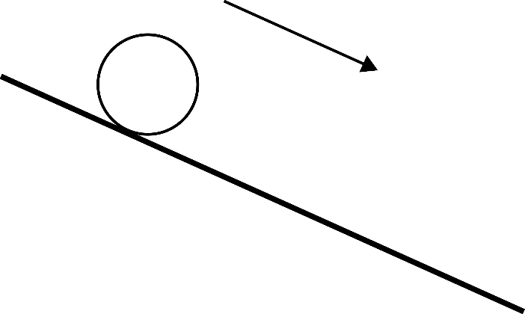
Direction of moving ball

The ball is held stationary at the top of the slope and then released.

The diagrams below compare the amount of energy in three different stores when the ball is at the top and bottom of the slope.
All the stores except the kinetic store at the bottom of the slope have been correctly drawn.
4a. Complete the diagrams below by shading in the correct number of squares for the kinetic store at the bottom of the slope.

Top Bottom

Gravitational | Kinetic | Thermal | Gravitational | Kinetic | Thermal

The ball is rolled down a longer, steeper slope.

The amount of energy in the thermal store at the top and bottom remains the same. The amount of energy in the gravitational store at the bottom remains the same.
These have been completed on the diagrams below.

4b. Complete the diagrams below by shading in the correct number of squares for each store for the steeper slope.
Top Bottom

Gravitational | Kinetic | Thermal | Gravitational | Kinetic | Thermal

4c. What are the names of the two pathways involved as the ball rolls down the hill?
2
Tick (✓)
Chemical reaction
Electrical
Gravitational
Heating
Mechanical
Radiation

2

The ball is speeding up down the slope.

4d. What can you say about the forces on any object as it speeds up?

Air resistance is a contact force.
1

4e. Which of the following is also a contact force?

Tick the correct answer.

Tick (✓)
Friction
Gravity
Magnetism
Weight

1

END OF ASSESSMENT

COPYRIGHT NOTICE:
Certain elements of this assessment may contain materials owned by third parties. For confidentiality purposes, all acknowledgements of third-party copyright material are published in a separate booklet here. Every effort has been made to obtain necessary permissions and acknowledgments for such content. If you believe your rights have been infringed or if you have any questions regarding the use of third-party materials, please contact curriculumsupport@unitedlearning.org.uk.

